OEVC STRATEGIC PLAN 2026–2030
DONOR-ENHANCED DETAILED EDITION
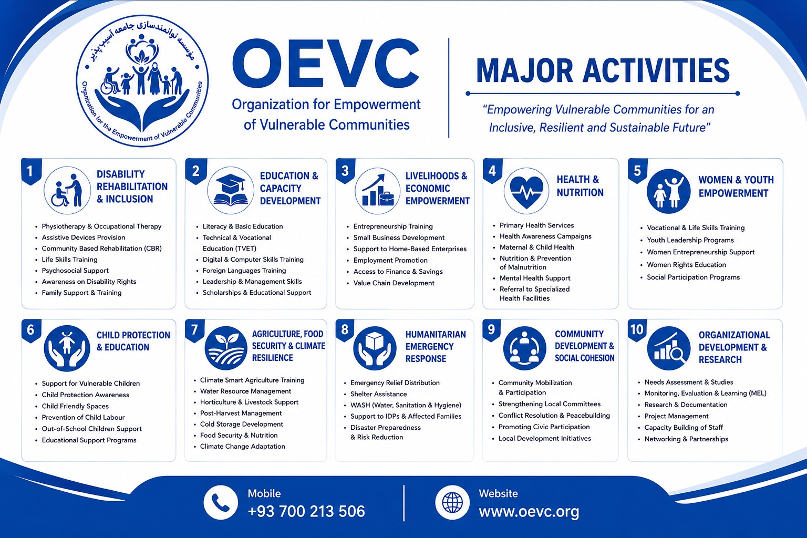
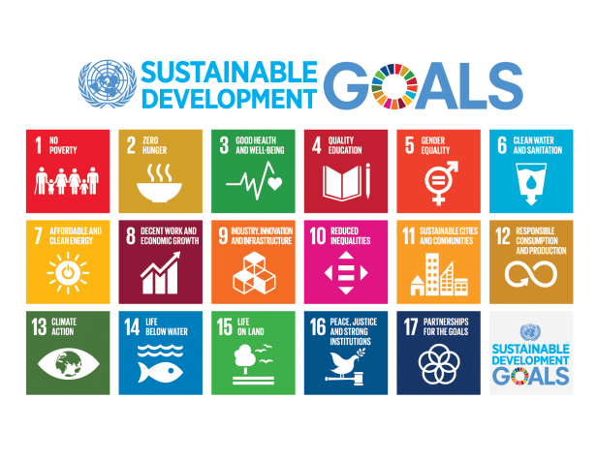

EXECUTIVE STRATEGIC SUMMARY
OEVC's 2026–2030 strategy is designed as a practical five-year framework for inclusive humanitarian action, sustainable development and locally led resilience. It focuses on people facing poverty and vulnerability, with particular attention to persons with disabilities, women and girls, children and youth, returnees, displaced households and underserved rural communities.
The strategy is organized around four interconnected impact areas: community empowerment and resilient development; disability inclusion, quality basic services and well-being; the right to food, livelihoods and climate resilience; and humanitarian response, protection and returnee resilience. Institutional quality, accountability, partnerships, resource mobilization and MEAL provide the enabling foundation.
DATA QUALITY NOTE: The source strategy provides illustrative indicators but does not provide numerical baselines or five-year targets. Numerical baselines and targets should be established through needs assessments, baseline exercises and annual operational planning rather than invented in the strategic plan.

STRATEGIC IMPACT AREA 01
Community Empowerment & Resilient Development
SDG LINKAGES: SDG 1, 10, 16, 17
OEVC seeks to strengthen the ability of vulnerable individuals and communities to organize, participate, access opportunities and withstand shocks.
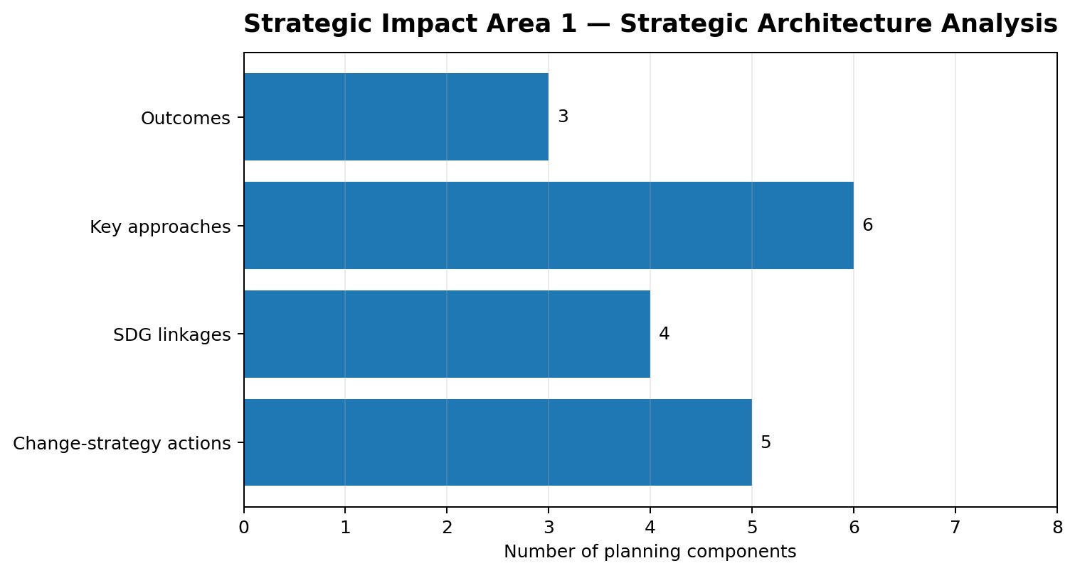
INTENDED OUTCOMES
• Communities have stronger local capacities and participation mechanisms.
• Vulnerable people have increased access to skills and economic opportunities.
• Community-based structures are better able to identify needs and respond collectively.
KEY APPROACHES
• Community assessments and participatory planning.
• Skills and vocational development.
• Entrepreneurship and inclusive livelihoods.
• Support to community groups and local organizations.
• Social cohesion and community resilience.
• Referral and linkage to relevant services.
CHANGE PATHWAY
If OEVC works with communities to identify priorities, strengthens local capacities and connects vulnerable people to skills, services and opportunities, communities will be better able to address immediate needs and build longer-term resilience.
ILLUSTRATIVE INDICATOR & DATA FRAMEWORK
• Indicator: People accessing inclusive services. | Data: Disaggregated participant/service-access records; training completion records; community action plans; referral records; feedback and complaints logs; outcome monitoring.
• Indicator: Learners completing skills programmes. | Data: Disaggregated participant/service-access records; training completion records; community action plans; referral records; feedback and complaints logs; outcome monitoring.
• Indicator: Community structures demonstrating stronger participation mechanisms. | Data: Disaggregated participant/service-access records; training completion records; community action plans; referral records; feedback and complaints logs; outcome monitoring.
• Indicator: Community feedback resolved within agreed standards. | Data: Disaggregated participant/service-access records; training completion records; community action plans; referral records; feedback and complaints logs; outcome monitoring.
DONOR ANALYSIS
Present this area as a results chain: identified need → targeted intervention → immediate output → service/behavior change → outcome → longer-term resilience. Annual targets should be set after baseline or needs-assessment evidence is available.

STRATEGIC IMPACT AREA 02
Disability Inclusion, Quality Basic Services & Well-being
SDG LINKAGES: SDG 3, 4, 5, 10
Access to quality basic services is central to dignity and resilience. OEVC combines disability inclusion with education, health, rehabilitation, psychosocial well-being and referral systems.
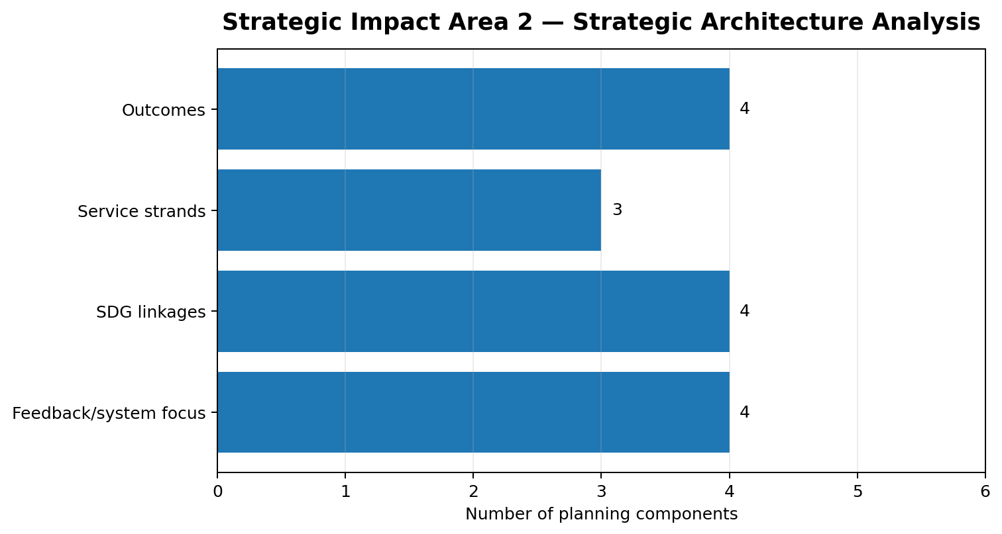
INTENDED OUTCOMES
• Persons with disabilities have improved access to rehabilitation and assistive support.
• Children and youth have improved access to inclusive learning and skills.
• Vulnerable communities have improved access to health and well-being services.
• Service barriers are identified and addressed through community and partner engagement.
KEY APPROACHES
• Community-based identification and rehabilitation referral.
• Assistive products and caregiver support.
• Awareness and inclusion in education and livelihoods.
• Inclusive learning, skills development and pathways to employment.
• Health promotion, referral, nutrition awareness and psychosocial support linkages.
• Community feedback on accessibility, appropriateness and respect.
CHANGE PATHWAY
OEVC will support direct service access where appropriate while strengthening the systems around that access, with persons with disabilities treated as rights-holders and contributors, not only beneficiaries.
ILLUSTRATIVE INDICATOR & DATA FRAMEWORK
• Indicator: Persons with disabilities accessing rehabilitation and assistive support. | Data: Disaggregated disability/service records; referral and assistive-device tracking; learning participation and completion data; caregiver/service feedback; accessibility assessments.
• Indicator: People accessing inclusive services. | Data: Disaggregated disability/service records; referral and assistive-device tracking; learning participation and completion data; caregiver/service feedback; accessibility assessments.
• Indicator: Learners completing skills programmes. | Data: Disaggregated disability/service records; referral and assistive-device tracking; learning participation and completion data; caregiver/service feedback; accessibility assessments.
• Indicator: Service barriers identified and addressed. | Data: Disaggregated disability/service records; referral and assistive-device tracking; learning participation and completion data; caregiver/service feedback; accessibility assessments.
DONOR ANALYSIS
Present this area as a results chain: identified need → targeted intervention → immediate output → service/behavior change → outcome → longer-term resilience. Annual targets should be set after baseline or needs-assessment evidence is available.

STRATEGIC IMPACT AREA 03
Right to Food, Livelihoods & Climate Resilience
SDG LINKAGES: SDG 1, 2, 5, 8, 13
Vulnerable households need resilient livelihoods and food systems that can withstand climate and economic shocks.
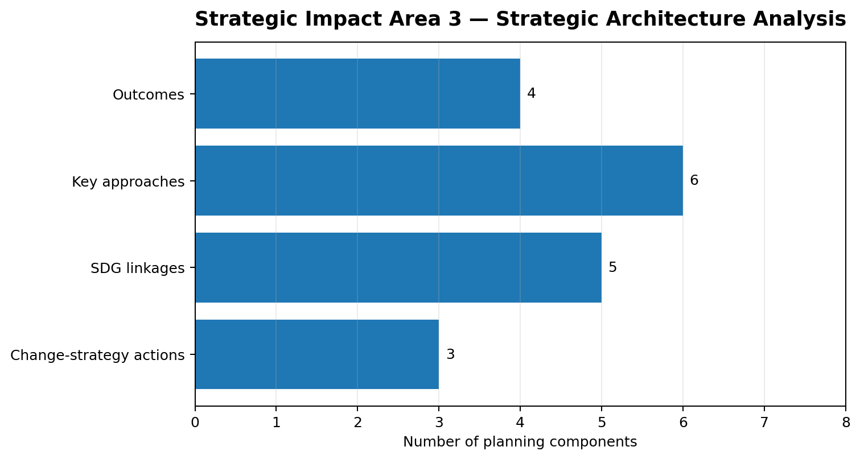
INTENDED OUTCOMES
• Households improve livelihood security and income opportunities.
• Farmers and producers strengthen production, post-harvest and market practices.
• Communities increase their capacity for climate adaptation and disaster risk reduction.
• Women, youth and persons with disabilities gain more inclusive access to economic opportunities.
KEY APPROACHES
• Climate-smart agriculture.
• Small-scale irrigation and water management.
• Agricultural value chains and post-harvest management.
• Vocational and entrepreneurship skills.
• Market linkages and producer groups.
• Disaster-risk mapping and preparedness.
CHANGE PATHWAY
OEVC will support communities to address livelihood and climate risks collectively. Producer and community groups can improve access to knowledge, markets, finance and mutual support.
ILLUSTRATIVE INDICATOR & DATA FRAMEWORK
• Indicator: Households reporting improved livelihood resilience. | Data: Household livelihood monitoring; farm/practice adoption records; training and enterprise records; market-linkage documentation; community risk maps and preparedness plans.
• Indicator: Farmers adopting climate-resilient practices. | Data: Household livelihood monitoring; farm/practice adoption records; training and enterprise records; market-linkage documentation; community risk maps and preparedness plans.
• Indicator: People gaining inclusive economic opportunities. | Data: Household livelihood monitoring; farm/practice adoption records; training and enterprise records; market-linkage documentation; community risk maps and preparedness plans.
• Indicator: Communities with preparedness plans. | Data: Household livelihood monitoring; farm/practice adoption records; training and enterprise records; market-linkage documentation; community risk maps and preparedness plans.
DONOR ANALYSIS
Present this area as a results chain: identified need → targeted intervention → immediate output → service/behavior change → outcome → longer-term resilience. Annual targets should be set after baseline or needs-assessment evidence is available.

STRATEGIC IMPACT AREA 04
Humanitarian Response, Protection & Returnee Resilience
SDG LINKAGES: SDG 1, 3, 5, 10, 16
Humanitarian needs can change quickly. OEVC will maintain capacity to respond to urgent needs while linking emergency assistance with protection, recovery and resilience.
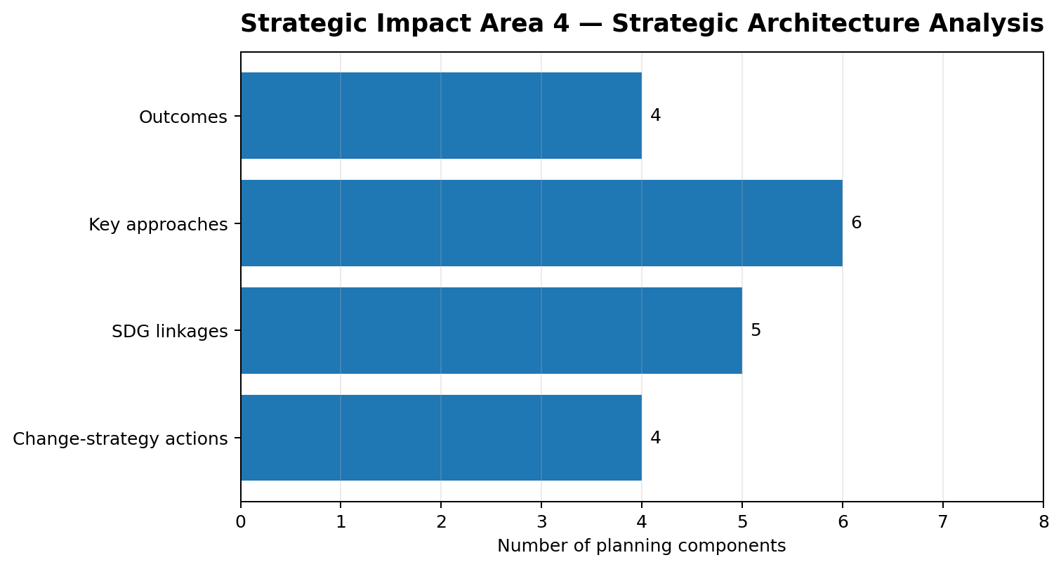
INTENDED OUTCOMES
• Vulnerable households receive timely and appropriate assistance.
• Returnees and host communities are better connected to services and livelihood opportunities.
• Community preparedness and disaster response capacities improve.
• Safeguarding and protection are integrated across programmes.
KEY APPROACHES
• Rapid needs assessment.
• Emergency assistance and referrals.
• Cash or in-kind assistance where appropriate.
• Protection and safeguarding referral.
• Emergency livelihood recovery.
• Disaster preparedness and community response planning.
CHANGE PATHWAY
OEVC will strengthen the link between humanitarian response and longer-term resilience. Emergency assistance should protect dignity and reduce immediate harm while, where feasible, connecting households with services, livelihoods and community support.
ILLUSTRATIVE INDICATOR & DATA FRAMEWORK
• Indicator: People receiving timely humanitarian support. | Data: Rapid assessment records; assistance distribution records; referral tracking; protection/safeguarding incident and referral logs; preparedness plans; community feedback.
• Indicator: Returnees/host communities connected to services and livelihoods. | Data: Rapid assessment records; assistance distribution records; referral tracking; protection/safeguarding incident and referral logs; preparedness plans; community feedback.
• Indicator: Communities with preparedness plans. | Data: Rapid assessment records; assistance distribution records; referral tracking; protection/safeguarding incident and referral logs; preparedness plans; community feedback.
• Indicator: Safeguarding/protection actions completed and concerns safely addressed. | Data: Rapid assessment records; assistance distribution records; referral tracking; protection/safeguarding incident and referral logs; preparedness plans; community feedback.
DONOR ANALYSIS
Present this area as a results chain: identified need → targeted intervention → immediate output → service/behavior change → outcome → longer-term resilience. Annual targets should be set after baseline or needs-assessment evidence is available.

INSTITUTIONAL QUALITY, ACCOUNTABILITY & SUSTAINABILITY
• Governance and leadership; financial management and internal controls; human resources and staff development.
• MEAL and data quality; safeguarding and PSEA; procurement and operational systems.
• Partnership due diligence; resource mobilization; communications and visibility.
• Digitalization and knowledge management.
The objective is not growth for its own sake. Institutional development is pursued to improve programme quality, accountability, efficiency and sustainability.

2026–2030 IMPLEMENTATION ROADMAP
2026 — FOUNDATION
Establish and strengthen core systems, launch priority programmes, build partnerships and operationalize MEAL and safeguarding.
2027 — EXPANSION
Scale effective models, strengthen community structures and diversify resource mobilization.
2028 — MID-TERM REVIEW
Assess progress, learning, context and institutional capacity; revise priorities where evidence requires.
2029 — CONSOLIDATION AND SCALING
Deepen successful programmes, strengthen evidence and expand strategic partnerships.
2030 — SUSTAINABILITY AND NEXT STRATEGY
Complete final evaluation, document learning, strengthen sustainable models and prepare the 2031–2035 strategy.

RESULTS, MEAL & DATA MANAGEMENT
The MEAL system connects strategy, programmes and organizational learning through baselines and needs assessments, results frameworks, routine monitoring, data-quality checks, community feedback, outcome monitoring, annual performance reviews, a 2028 mid-term review and a 2030 final evaluation.
• People accessing inclusive services.
• Persons with disabilities accessing rehabilitation and assistive support.
• Learners completing skills programmes.
• Households reporting improved livelihood resilience.
• Farmers adopting climate-resilient practices.
• People receiving timely humanitarian support.
• Communities with preparedness plans.
• Community feedback resolved within agreed standards.
• Funding sources diversified.
• Audit, safeguarding and compliance actions completed.

SCA EXPERIENCE → OEVC FUTURE DIRECTION
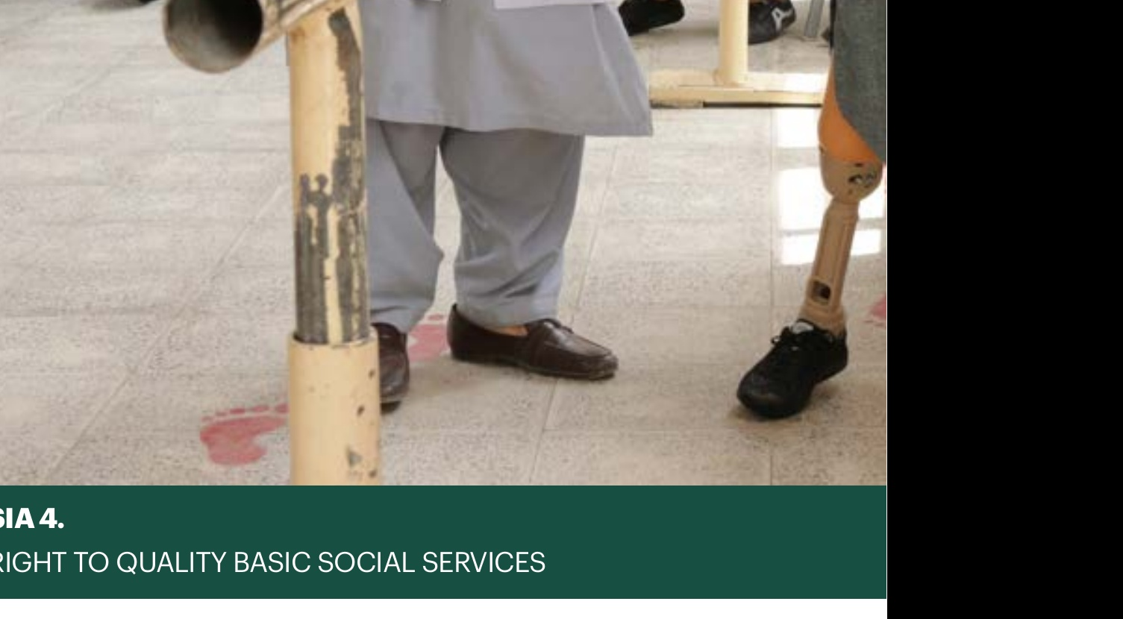
The SCA experience should be presented as relevant technical and institutional learning. It should not be presented as OEVC's own historical results or as evidence that the organizations are the same. Current OEVC capacity, registration, systems, staff, partnerships and proposed delivery arrangements should be documented separately in donor proposals.

DONOR READINESS CHECKLIST
• Clear problem statement, target groups, geographic scope, theory of change and results framework.
• Baseline/needs-assessment plan and data source for each selected indicator.
• Activity-based budget linked to outputs, outcomes and annual workplan.
• Safeguarding/PSEA policies, focal points, referral pathways and complaints mechanism.
• Indicator definitions, frequency, responsibility, data source, quality checks and learning use.
• Partner roles, due diligence and mutual accountability arrangements.
• Resource diversification, local ownership, institutional strengthening and sustainability measures.
• Consent-based photography, case studies and donor-compliant communications.
• Context, access, financial, safeguarding, climate and operational risk matrix with mitigations.

FULL OEVC STRATEGIC PLAN — SOURCE CONTENT
OEVC STRATEGIC PLAN 2026–2030
Organization for Empowerment of Vulnerable Communities
Empowering people • Strengthening communities • Building resilience

FOREWORD FROM THE FOUNDER & CEO
OEVC was established with a simple commitment: vulnerable people and communities should not be left without opportunity, dignity or support. This Strategic Plan 2026–2030 sets out how OEVC will translate that commitment into a focused programme of community empowerment, disability inclusion, essential services, resilient livelihoods and locally led development.
The strategy is deliberately designed for a changing Afghanistan. It combines practical service delivery with community ownership, partnership, learning and evidence. It recognizes that sustainable change requires both responses to urgent needs and investment in the capacities that enable families and communities to withstand future shocks.
OEVC will work with communities, organizations of persons with disabilities, local actors, national and international partners, donors and other stakeholders. We will remain accountable to the people we serve and committed to transparency, safeguarding, non-discrimination and responsible use of resources.
This strategy is a roadmap, not a rigid blueprint. OEVC will continuously analyse context, listen to communities, learn from implementation and adapt priorities so that available resources are used where they can create the greatest sustainable value.

BACKGROUND
Afghanistan remains a complex environment in which humanitarian needs, poverty, displacement, limited employment, climate shocks and barriers to basic services overlap. Vulnerable households are often exposed to several risks at the same time.
The reference strategy shared with OEVC places strong emphasis on locally rooted approaches, community-based structures, resilience, livelihoods, food security, climate adaptation and quality basic services. OEVC adopts this strategic logic while tailoring it to its own mandate and role as an Afghan national organization.
OEVC's strategic period therefore focuses on strengthening the ability of individuals, families and communities to access services, build livelihoods, participate in decisions that affect them and respond to shocks. Particular attention is given to persons with disabilities, women and girls, children and youth, returnees, displaced and other vulnerable households.

OUR VISION, MISSION, TARGET GROUPS AND CORE VALUES
VISION
An Afghanistan where vulnerable people live with dignity, equal opportunity, resilience and meaningful participation.
MISSION
To empower vulnerable communities through inclusive humanitarian assistance, sustainable development, disability inclusion, essential services, livelihoods, partnerships and locally led solutions.
TARGET GROUPS
People living in poverty and with vulnerabilities, with particular attention to persons with disabilities, women and girls, children and youth, returnees, displaced households and underserved rural communities.
CORE VALUES
Participation • Equality • Non-discrimination • Accountability • Transparency • Integrity • Local ownership • Partnership • Inclusion • Sustainability
OEVC will apply these values not only to programmes but also to internal management, partnerships, fundraising, communications and decision-making.

OUR ANALYSIS OF THE OPERATING CONTEXT
OEVC sees four interconnected realities shaping its work:
1. Persistent vulnerability. Poverty, unemployment and limited access to services continue to affect household resilience.
2. Unequal access. Persons with disabilities and other marginalized groups can face physical, social, economic and institutional barriers.
3. Climate and livelihood pressure. Drought, floods, water stress, agricultural losses and weak market access can deepen food insecurity and poverty.
4. A changing aid environment. Reduced and shifting international financing increases the importance of local leadership, efficient partnerships, evidence and diversified resource mobilization.
OEVC will use annual context analysis to refine geographic and thematic priorities. The organization will remain agile and avoid treating the 2026–2030 plan as a fixed list of activities.

HOW WE BELIEVE SUSTAINABLE SOCIAL CHANGE CAN HAPPEN
Change is possible when people have the knowledge, opportunities, services and support needed to improve their lives and when communities have the capacity to organize, participate and respond to challenges.
Change is strengthened when local organizations and community structures are trusted, capable and connected to wider systems of support. Accountability also matters: institutions, partners and service providers need to understand responsibilities and respond to legitimate needs.
OEVC believes that durable progress is more likely when solutions are locally rooted, culturally informed, inclusive and developed with the people affected. Direct assistance can meet urgent needs, but empowerment, skills, social networks, resilient livelihoods and community systems are essential to reduce long-term vulnerability.

OEVC'S CONTRIBUTION TO CHANGE
OEVC will contribute through three mutually reinforcing strategic means:
1. PARTNERSHIPS FOR COMMUNITY CHANGE
OEVC will work with communities and local structures to deliver practical programmes, strengthen capacity and support locally owned solutions.
2. EVIDENCE, LEARNING AND INFLUENCE
OEVC will document experience, generate evidence, communicate community perspectives and use learning to improve programmes and contribute to constructive dialogue.
3. PUBLIC COMMITMENT AND RESOURCE MOBILIZATION
OEVC will communicate responsibly about community needs and results, strengthen donor and partner engagement, and mobilize resources for sustainable action.
Together, these approaches connect concrete improvements in people's lives with stronger local systems, learning and longer-term support.

OEVC'S ADDED VALUE
OEVC's added value is its local identity and proximity to communities. As an Afghan organization, OEVC can build relationships with community actors, understand local realities and adapt implementation to context.
OEVC's approach combines:
• Community ownership and participation.
• Disability-inclusive programming.
• Practical links between humanitarian assistance and longer-term resilience.
• Experience in disability, social services and community programming.
• A commitment to evidence, accountability and learning.
• Partnership-oriented implementation rather than isolated delivery.
OEVC will strengthen this added value through professional systems, staff development, safeguarding, financial controls, MEAL, research and transparent communication.

ALIGNMENT WITH INTERNATIONAL FRAMEWORKS
OEVC will align relevant programmes with the Sustainable Development Goals, humanitarian principles, disability inclusion standards, safeguarding expectations and applicable donor requirements.
Priority SDG linkages include:
SDG 1 — No Poverty
SDG 2 — Zero Hunger
SDG 3 — Good Health and Well-being
SDG 4 — Quality Education
SDG 5 — Gender Equality
SDG 8 — Decent Work and Economic Growth
SDG 10 — Reduced Inequalities
SDG 13 — Climate Action
SDG 16 — Peace, Justice and Strong Institutions
SDG 17 — Partnerships for the Goals
Alignment will be programme-specific and will be reviewed as relevant national and international frameworks evolve.

STRATEGIC IMPACT AREA 1
COMMUNITY EMPOWERMENT AND RESILIENT DEVELOPMENT
SDG LINKAGES: 1, 10, 16, 17
OEVC seeks to strengthen the ability of vulnerable individuals and communities to organize, participate, access opportunities and withstand shocks.
OUTCOMES
• Communities have stronger local capacities and participation mechanisms.
• Vulnerable people have increased access to skills and economic opportunities.
• Community-based structures are better able to identify needs and respond collectively.
KEY APPROACHES
• Community assessments and participatory planning.
• Skills and vocational development.
• Entrepreneurship and inclusive livelihoods.
• Support to community groups and local organizations.
• Social cohesion and community resilience.
• Referral and linkage to relevant services.
OEVC will prioritize models that can be maintained or expanded through local capacity and partnerships.

STRATEGIC IMPACT AREA 1
CHANGE STRATEGIES
If OEVC works with communities to identify priorities, strengthens local capacities and connects vulnerable people to skills, services and opportunities, then communities will be better able to address immediate needs and build longer-term resilience.
OEVC will support community structures to:
• identify barriers and vulnerable households;
• develop practical action plans;
• strengthen peer and mutual-support mechanisms;
• connect people with service providers and markets;
• monitor whether interventions are reaching excluded groups.
Persons with disabilities will be supported to participate as rights-holders and contributors, not only as beneficiaries.

STRATEGIC IMPACT AREA 2
DISABILITY INCLUSION, QUALITY BASIC SERVICES AND WELL-BEING
SDG LINKAGES: 3, 4, 5, 10
Access to quality basic services is central to dignity and resilience. OEVC will combine disability inclusion with education, health, rehabilitation, psychosocial well-being and referral systems.
OUTCOMES
• Persons with disabilities have improved access to rehabilitation and assistive support.
• Children and youth have improved access to inclusive learning and skills.
• Vulnerable communities have improved access to health and well-being services.
• Service barriers are identified and addressed through community and partner engagement.

STRATEGIC IMPACT AREA 2
CHANGE STRATEGIES
OEVC will support direct service access where appropriate and strengthen the systems around that access.
In disability programming this includes community-based identification, rehabilitation referral, assistive products, caregiver support, awareness and inclusion in education and livelihoods.
In education it includes inclusive learning, skills development, teacher and community support and pathways to employment.
In health and well-being it includes health promotion, referral, rehabilitation, nutrition awareness and mental health and psychosocial support linkages.
OEVC will use community feedback to assess whether services are accessible, appropriate and respectful.

STRATEGIC IMPACT AREA 3
RIGHT TO FOOD, LIVELIHOODS AND CLIMATE RESILIENCE
SDG LINKAGES: 1, 2, 5, 8, 13
Vulnerable households need resilient livelihoods and food systems that can withstand climate and economic shocks.
OUTCOMES
• Households improve livelihood security and income opportunities.
• Farmers and producers strengthen production, post-harvest and market practices.
• Communities increase their capacity for climate adaptation and disaster risk reduction.
• Women, youth and persons with disabilities gain more inclusive access to economic opportunities.
KEY APPROACHES
• Climate-smart agriculture.
• Small-scale irrigation and water management.
• Agricultural value chains and post-harvest management.
• Vocational and entrepreneurship skills.
• Market linkages and producer groups.
• Disaster-risk mapping and preparedness.

STRATEGIC IMPACT AREA 3
CHANGE STRATEGIES
OEVC will support communities to address livelihood and climate risks collectively. Producer and community groups can improve access to knowledge, markets, finance and mutual support.
The organization will seek partnerships for agricultural infrastructure, resilient livelihoods, vocational training and climate adaptation. Programming will consider the specific barriers faced by women, persons with disabilities and other excluded groups.
Where appropriate, OEVC will connect community experience with evidence and policy dialogue so that local priorities inform wider discussions on food security, livelihoods and climate resilience.

STRATEGIC IMPACT AREA 4
HUMANITARIAN RESPONSE, PROTECTION AND RETURNEE RESILIENCE
SDG LINKAGES: 1, 3, 5, 10, 16
Humanitarian needs can change quickly. OEVC will maintain the capacity to respond to urgent needs while linking emergency assistance with protection, recovery and resilience.
OUTCOMES
• Vulnerable households receive timely and appropriate assistance.
• Returnees and host communities are better connected to services and livelihood opportunities.
• Community preparedness and disaster response capacities improve.
• Safeguarding and protection are integrated across programmes.
KEY APPROACHES
• Rapid needs assessment.
• Emergency assistance and referrals.
• Cash or in-kind assistance where appropriate.
• Protection and safeguarding referral.
• Emergency livelihood recovery.
• Disaster preparedness and community response planning.

STRATEGIC IMPACT AREA 4
CHANGE STRATEGIES
OEVC will strengthen the link between humanitarian response and longer-term resilience. Emergency assistance should protect dignity and reduce immediate harm while, where feasible, connecting households with services, livelihoods and community support.
Returnee and host-community programming will be designed around needs and vulnerabilities rather than status alone. OEVC will seek to strengthen referral networks and community preparedness.
Accountability to affected people will be integral: communities will receive understandable information, have opportunities to provide feedback and be able to raise concerns safely.

DEVELOPING WHO WE ARE AND HOW WE WORK
OEVC will invest in the institutional foundations required to deliver the strategy.
PRIORITIES
• Governance and leadership.
• Financial management and internal controls.
• Human resources and staff development.
• MEAL and data quality.
• Safeguarding and PSEA.
• Procurement and operational systems.
• Partnership due diligence.
• Resource mobilization.
• Communications and visibility.
• Digitalization and knowledge management.
The objective is not growth for its own sake. Institutional development will be pursued to improve programme quality, accountability, efficiency and sustainability.

PARTNERSHIPS FOR SUSTAINABLE CHANGE
OEVC views partnerships as long-term relationships based on complementary strengths, mutual accountability and local ownership.
OEVC will seek constructive cooperation with:
• Organizations of persons with disabilities.
• Community-based organizations and local groups.
• National and international NGOs.
• UN agencies and donors.
• Academic and research institutions.
• Private-sector actors.
• Relevant authorities and service providers.
Partnership selection will consider relevance, integrity, capacity, safeguarding, community legitimacy and potential for sustainable results.

RESOURCE MOBILIZATION AND FINANCIAL SUSTAINABILITY
OEVC will develop a diversified resource base to reduce dependence on a single funding source.
Priority approaches include:
• Institutional donor proposals.
• UN and pooled-fund opportunities where eligible.
• Foundation and philanthropic partnerships.
• Private-sector and CSR partnerships.
• Individual and diaspora giving.
• Appropriate social-enterprise and cost-recovery models.
• Multi-year partnerships.
Resource mobilization will be grounded in credible programme designs, evidence of results, transparent financial management, strong donor compliance and clear communication of impact.

MONITORING, EVALUATION, ACCOUNTABILITY AND LEARNING
OEVC will maintain a MEAL system that connects strategy, programmes and organizational learning.
The system will include:
• Baselines and needs assessments.
• Results frameworks and indicators.
• Routine monitoring and data-quality checks.
• Community feedback and complaints mechanisms.
• Outcome monitoring.
• Annual performance reviews.
• A mid-term strategic review in 2028.
• Final strategic evaluation in 2030.
• Learning products and management actions.
OEVC will use evidence not only to report to donors but to improve decisions and programme quality.

RISK MANAGEMENT AND ANTI-CORRUPTION
OEVC will continuously analyse contextual and operational risks and integrate mitigation into annual planning.
Risk areas include access, security, finance, fraud and corruption, safeguarding, programme quality, reputation, climate, supply chains and staff capacity.
OEVC will strengthen segregation of duties, authorization controls, partner due diligence, financial monitoring, incident reporting, whistleblowing and management oversight. Roles and responsibilities for risk management will be clearly defined and reviewed.

REVISITING OUR VALUES AND HOW THEY ARE PRACTICED
OEVC's values must be visible in everyday decisions.
We will respect the dignity and agency of the people we serve; treat people fairly without discrimination; recognize differences in needs and capabilities; work with communities rather than for communities alone; communicate honestly; protect confidential information; and remain accountable for the resources entrusted to us.
OEVC will regularly revisit how these values are practiced through staff learning, community feedback, partner dialogue, leadership review and programme quality processes.

STRATEGIC ROADMAP 2026–2030
2026 — FOUNDATION
Establish and strengthen core systems, launch priority programmes, build partnerships and operationalize MEAL and safeguarding.
2027 — EXPANSION
Scale effective models, strengthen community structures and diversify resource mobilization.
2028 — MID-TERM REVIEW
Assess progress, learning, context and institutional capacity; revise priorities where evidence requires.
2029 — CONSOLIDATION AND SCALING
Deepen successful programmes, strengthen evidence and expand strategic partnerships.
2030 — SUSTAINABILITY AND NEXT STRATEGY
Complete final evaluation, document learning, strengthen sustainable models and prepare the 2031–2035 strategy.

RESULTS FRAMEWORK
IMPACT
Vulnerable communities experience greater inclusion, resilience, dignity and opportunity.
OUTCOME LEVEL
1. Stronger community empowerment and resilient development.
2. Improved access to disability-inclusive basic services and well-being.
3. Improved food security, livelihoods and climate resilience.
4. Stronger humanitarian response, protection and returnee resilience.
5. Stronger institutional quality, accountability and sustainability.
ILLUSTRATIVE INDICATORS
• People accessing inclusive services.
• Persons with disabilities accessing rehabilitation and assistive support.
• Learners completing skills programmes.
• Households reporting improved livelihood resilience.
• Farmers adopting climate-resilient practices.
• People receiving timely humanitarian support.
• Communities with preparedness plans.
• Community feedback resolved within agreed standards.
• Funding sources diversified.
• Audit, safeguarding and compliance actions completed.

SDG ALIGNMENT MATRIX
OEVC's strategic priorities contribute to:
SDG 1 — poverty reduction through livelihoods and resilience.
SDG 2 — food security through agriculture and climate-smart production.
SDG 3 — health, rehabilitation and well-being.
SDG 4 — inclusive education and skills.
SDG 5 — equitable participation and gender-sensitive programming.
SDG 8 — employment, entrepreneurship and livelihoods.
SDG 10 — disability inclusion and reduced inequalities.
SDG 13 — climate adaptation and disaster-risk reduction.
SDG 16 — accountable institutions, protection and participation.
SDG 17 — partnerships and resource mobilization.

IMPLEMENTATION, REVIEW AND ADAPTATION
The Strategic Plan will be implemented through annual operational plans and budgets. Each year OEVC will review context, programme performance, resource availability, risks and learning.
Management will translate strategic outcomes into annual targets and project-level results frameworks. Programme teams will report progress through routine monitoring and quarterly reviews. Senior management will use evidence to adjust implementation, while the Board will provide strategic oversight.
The 2028 mid-term review will assess relevance, effectiveness, organizational capacity, partnership performance and progress toward outcomes. The 2030 evaluation will inform the next strategic cycle.

ANNEX: STRATEGIC MANAGEMENT CYCLE
Context analysis → strategic prioritization → annual operational planning → budgeting and resource mobilization → implementation → monitoring and community feedback → quarterly review → learning and adaptation → annual performance review → strategic mid-term review → final evaluation → next strategy.
This cycle ensures that OEVC's strategy remains relevant in a changing environment while maintaining a clear long-term direction.

