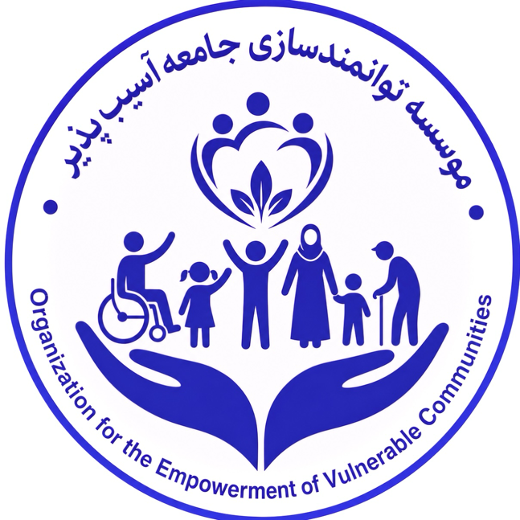

ORGANIZATION FOR EMPOWERMENT VULNERABLE COMMUNITIES (OEVC)

ORGANIZATIONAL FACTSHEET

Empowering Communities • Promoting Inclusion • Building Resilience

1. ORGANIZATION AT A GLANCE
Organization Name: Organization for Empowerment Vulnerable Communities (OEVC)
Acronym: OEVC
Organization Type: Non-Governmental, Non-Profit Organization
Legal Status: Registered with the Ministry of Economy of Afghanistan
Head Office: Balkh Province, Afghanistan
Founder & CEO: Mohammad Ramiz Yousufi
Working Languages: Dari, Pashto and English
Primary Geographic Focus: Balkh, Jawzjan and Samangan
Programme Scope: Humanitarian, Social Development and Community Resilience

2. WHO WE ARE
The Organization for Empowerment Vulnerable Communities (OEVC) is an Afghan non-governmental, non-profit organization committed to empowering vulnerable and underserved communities through inclusive, community-based and sustainable interventions.
OEVC places particular emphasis on persons with disabilities, vulnerable households, women, children, youth and communities affected by poverty, displacement, limited access to services and socioeconomic vulnerability.
The organization combines local knowledge, community engagement and programme implementation capacity to develop practical solutions that improve access to essential services, strengthen livelihoods and promote inclusion and resilience.

3. OUR VISION
An inclusive, empowered and resilient Afghanistan where vulnerable communities have equitable access to opportunities, essential services and sustainable livelihoods.

4. OUR MISSION
To empower vulnerable communities through inclusive humanitarian and development programmes that strengthen access to services, promote disability inclusion, improve livelihoods, support education and health, and build resilient communities through meaningful participation and locally led solutions.

5. CORE PROGRAMME AREAS

♿ Disability Inclusion & Rehabilitation
- Disability rehabilitation and community-based support
- Inclusion of persons with disabilities
- Awareness and advocacy
- Community-based rehabilitation approaches
- Referral and access to essential services
- Participation of persons with disabilities in community life

🎓 Education
- Inclusive education
- Support for children and students with disabilities
- Community education initiatives
- Education awareness and outreach
- Capacity building for teachers and community stakeholders

🌾 Agriculture & Livelihoods
- Agricultural livelihood development
- Support to vulnerable farming households
- Women’s economic empowerment
- Skills development and vocational opportunities
- Climate-smart and resilient livelihoods
- Market-oriented community initiatives

🏥 Health & Social Services
- Community-based health awareness
- Social support services
- Referral and linkage to essential services
- Support to vulnerable households
- Community awareness and outreach

🌱 Climate Resilience & Community Development
- Climate-resilient livelihoods
- Environmental awareness
- Green and inclusive community initiatives
- Disaster and vulnerability preparedness
- Community-led resilience solutions

6. GEOGRAPHICAL FOCUS
OEVC’s current strategic geographical focus is:
Balkh Province
Jawzjan Province
Samangan Province
The organization is prepared to expand its operational coverage to additional provinces based on donor requirements, programme needs, partnerships and available resources.
OEVC’s local presence and community relationships provide a strong foundation for locally led programme implementation and beneficiary engagement.

7. OUR TARGET GROUPS
OEVC prioritizes support to:
- Persons with disabilities
- Children and students with disabilities
- Women and girls
- Vulnerable households
- Children and youth
- Smallholder farmers
- Economically vulnerable communities
- Displaced and crisis-affected populations
- Underserved rural and urban communities
OEVC applies an inclusion and do-no-harm approach, seeking to ensure that vulnerable groups are meaningfully involved in programme design, implementation and monitoring.

8. ORGANIZATIONAL EXPERIENCE & CAPACITY
OEVC’s institutional and technical capacity is informed by experienced Afghan professionals with backgrounds in humanitarian, development and disability-focused programming.
The organization’s leadership and technical experience includes engagement in programmes supported by international development and humanitarian partners, including experience associated with EU-funded disability inclusion programming and work with organizations such as the Swedish Committee for Afghanistan (SCA) and the Norwegian Afghanistan Committee (NAC).
This experience has contributed to OEVC’s capacity in:
- Programme planning and implementation
- Disability inclusion
- Community mobilization
- Stakeholder coordination
- Monitoring and reporting
- Data collection and analysis
- Project management
- Capacity building
- Partnership and donor engagement

9. OUR APPROACH
OEVC follows a community-based, inclusive and locally led approach.
Our programming is guided by:
Participation – Communities are involved in identifying priorities and solutions.
Inclusion – Persons with disabilities and other marginalized groups are intentionally included.
Accountability – We promote transparency, responsible resource management and feedback mechanisms.
Sustainability – Programmes aim to build local capacity and long-term resilience.
Partnership – OEVC works collaboratively with government institutions, communities, civil society, donors and international organizations.
Evidence-Based Programming – Decisions are informed by needs assessments, data, community feedback and programme learning.

10. PARTNERSHIP OPPORTUNITIES
OEVC welcomes strategic collaboration with international NGOs, UN agencies, donors, foundations, civil society organizations and private-sector partners.
Potential partnership models include:
- Joint programme implementation
- Consortium partnerships
- Joint fundraising
- Co-application for grants and contracts
- Sub-granting arrangements
- Sub-contracting arrangements
- Local implementation partnerships
- Technical partnerships
- Research and assessment
- Capacity-building initiatives
- Community-based humanitarian response
OEVC is particularly interested in partnerships that combine international fundraising and technical resources with strong Afghan local implementation capacity.

11. WHY PARTNER WITH OEVC?

Local Knowledge
Strong understanding of local communities, needs and operating contexts.

Community Access
Community-based engagement with vulnerable and underserved populations.

Disability Expertise
Specific institutional focus and experience in disability inclusion and rehabilitation.

Local Implementation Capacity
Ability to support field-level programme implementation, coordination and monitoring.

Experienced Leadership
Leadership with experience in humanitarian, development and disability-focused programmes.

Flexible Partnership Model
Ability to work as a lead organization, consortium partner, delivery partner, sub-grantee or sub-contractor, subject to donor requirements.

Commitment to Accountability
Focus on transparency, responsible management, safeguarding and quality programme delivery.

12. STRATEGIC PRIORITIES 2026–2030
OEVC’s Strategic Plan 2026–2030 focuses on strengthening the organization’s institutional capacity while expanding high-quality programmes for vulnerable communities.
Key strategic priorities include:
- Strengthening disability inclusion and rehabilitation services.
- Expanding inclusive education opportunities.
- Improving livelihoods and agricultural resilience.
- Strengthening community health and social services.
- Promoting women’s and youth empowerment.
- Supporting climate resilience and environmentally sustainable initiatives.
- Strengthening local community structures and participation.
- Building institutional, financial and technical sustainability.
- Developing strategic partnerships and diversified funding.
- Strengthening monitoring, evaluation, accountability and learning.

13. COMMITMENT TO PARTNERS
OEVC is committed to developing partnerships based on:
Trust • Transparency • Accountability • Complementarity • Local Ownership • Measurable Impact
We believe that sustainable change is achieved when international resources, technical expertise and local knowledge are brought together through effective partnerships.

HUMAN CAPITAL & TECHNICAL FIELD CAPACITY

Local Expertise. Proven Experience. Community Reach.

119 Experienced Volunteers | 3 Provinces | Strong Female Participation
OEVC’s operational strength is built on a locally rooted and technically experienced human resource network. Across Balkh, Jawzjan, and Samangan, OEVC works with 119 trained and experienced volunteers who contribute their professional knowledge, field experience, and understanding of local communities to support inclusive and effective programme delivery.
The network includes 59 male and 60 female volunteers, providing OEVC with a strong and balanced capacity to engage diverse communities, including women, persons with disabilities, vulnerable households, and other underserved groups.

A Team Built on Practical Field Experience
OEVC’s volunteer network is not simply a community outreach mechanism. It represents a pool of experienced field-based human resources with practical exposure to humanitarian, development, disability, education, social service, and community-based programming.
A number of OEVC team members have gained valuable professional experience through their previous engagement with the Swedish Committee for Afghanistan (SCA) and other development and humanitarian initiatives. This background has contributed to the team’s understanding of professional programme standards, community engagement approaches, field coordination, reporting, monitoring, and inclusive programming.

Technical Competencies
The team brings practical capacity in:
Disability & Inclusion
Community-based disability inclusion, identification of needs, referral support, awareness, and participation of persons with disabilities.
Community Engagement
Community mobilization, consultation, awareness raising, relationship building, and participatory approaches.
Programme Implementation
Field-level activity implementation, coordination, documentation, follow-up, and community-based support.
Monitoring & Reporting
Field data collection, beneficiary follow-up, activity monitoring, documentation, and reporting support.
Education & Social Services
Community awareness, educational support, social service engagement, and assistance to vulnerable groups.
Coordination & Partnerships
Engagement with community representatives, local stakeholders, institutions, and programme partners.

Our Geographic Human Resource Footprint
Province | Male | Female | Total
Balkh | 29 | 30 | 59
Jawzjan | 10 | 15 | 25
Samangan | 20 | 15 | 35
TOTAL | 59 | 60 | 119

What This Means for Partners & Donors
OEVC’s volunteer network provides a ready, locally embedded human resource platform that can support programme expansion without relying exclusively on newly recruited personnel.
The combination of professional experience, technical knowledge, local language and cultural understanding, community relationships, and field presence enables OEVC to identify needs, mobilize communities, support implementation, and maintain communication at the local level.
This structure also strengthens OEVC’s ability to:
- Reach communities beyond the main provincial centres
- Engage women and vulnerable groups more effectively
- Understand local needs and priorities
- Mobilize experienced personnel rapidly
- Support inclusive and community-driven programming
- Strengthen field monitoring and accountability
- Build trusted relationships with communities and stakeholders

A Strategic Institutional Asset
OEVC views its volunteer network as more than a workforce—it is a strategic institutional asset.
The experience accumulated by team members through previous humanitarian and development programmes, including experience associated with SCA, provides OEVC with valuable institutional knowledge and practical understanding of field-level programme delivery.
OEVC is committed to further strengthening this human resource base through continuous learning, technical training, mentoring, knowledge sharing, and professional development, ensuring that its growing network remains capable of meeting evolving community needs and donor expectations.

119 PEOPLE. 3 PROVINCES. ONE SHARED COMMITMENT.
Empowering communities. Promoting inclusion. Delivering locally driven solutions.

CONTACT
Organization for Empowerment Vulnerable Communities (OEVC)
Founder & CEO: Mohammad Ramiz Yousufi
Location: Balkh Province, Afghanistan
Email: info@oevc.org
www.oevc.org
Phone/WhatsApp: +93 700 213 506
Languages: English | Dari | Pashto

“Empowering Communities. Promoting Inclusion. Building Resilience.”

